CSA1518-CLOUD COMPUTING

V.MRUDULA

192011395

EXPT:18

Create a Storage service using any Public Cloud Service Provider (Azure/GCP/AWS) and check the public accessibility of the stored file to demonstrate Storage as a Service.

IMPLEMENTATION:

STEP 1: GO TO APP SERVICE TO CREATE A WEBAPP.

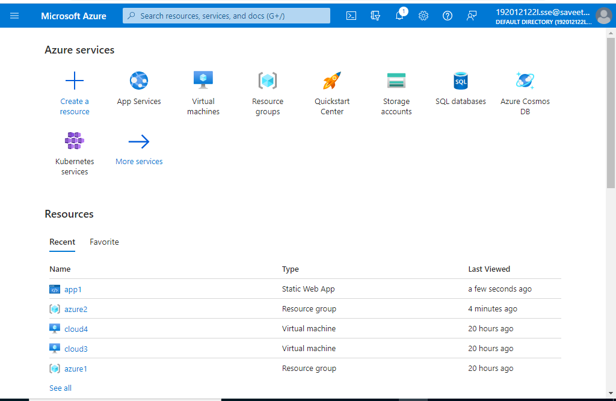

STEP 2: SELECT CREATE AND CLICK ON WEB APP

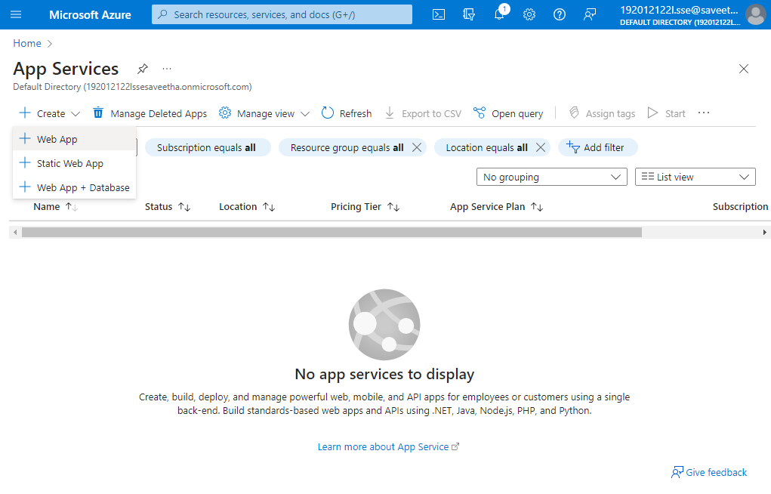

STEP 3: AFTER ENTER THE ALL THE NECESSARY THINGS CLICK THE REVIEW AND CREATE AND CLICK THE CREATE THE WEB APP.

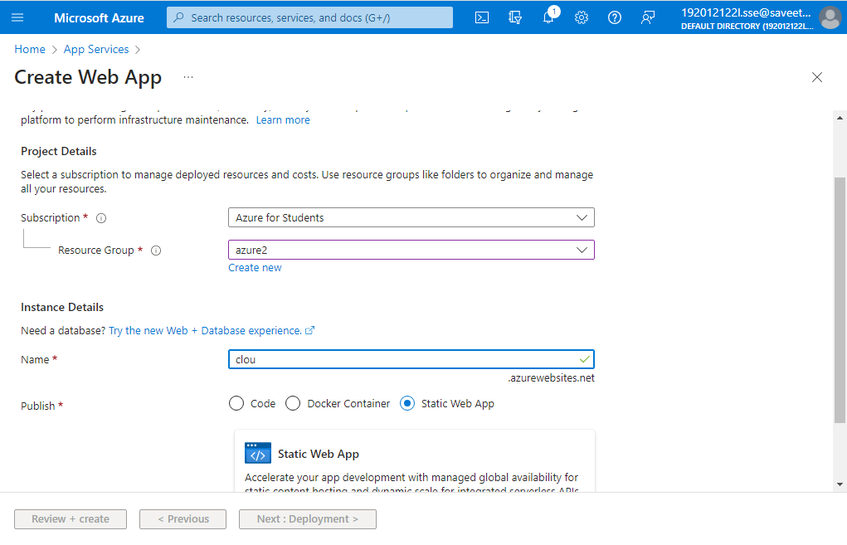

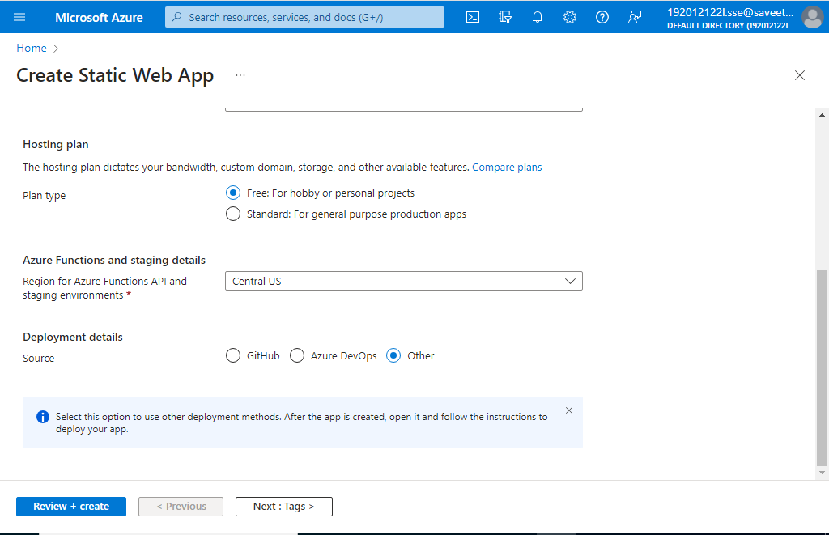

STEP 4:GIVE NAME AND VALUES FOR TAGS

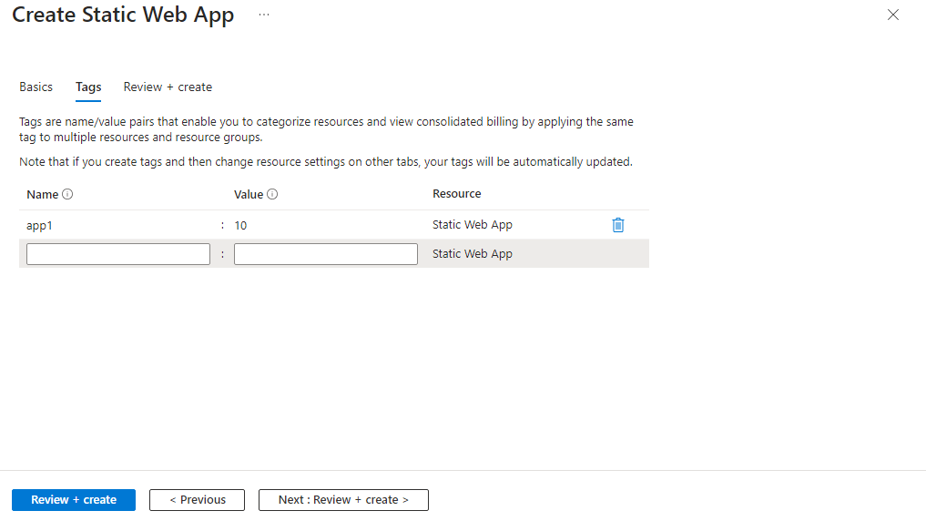

STEP 5:CLICK ON CREATE

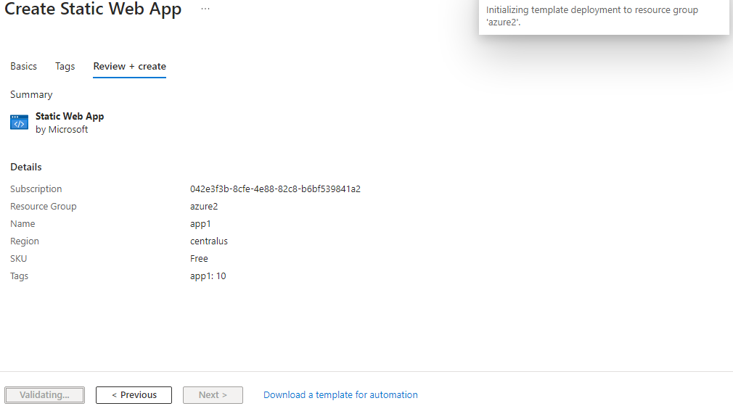

STEP 6:CLICK ON GO TO RESOURCE AFTER DEPLOYMENT IS CREATED

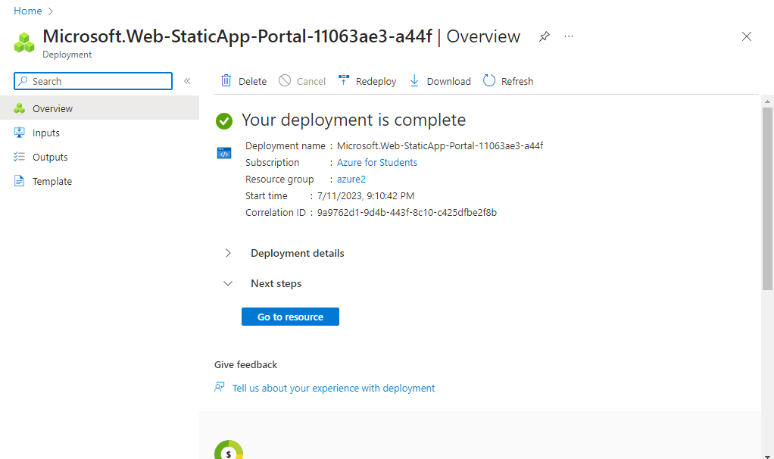

STEP 7: GOTO WEBSITE URL LINK.

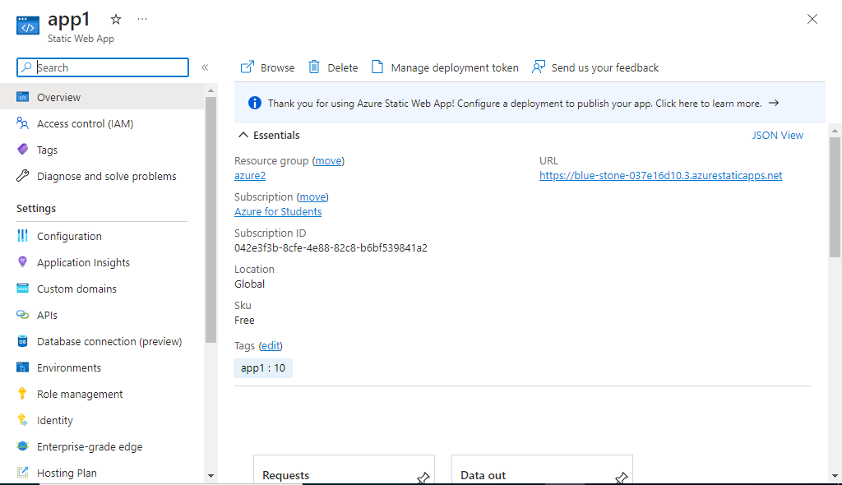

STEP 8: THIS IS OUR WEBAPP SERVICE.

